**HOW TO ADD LEAVE CREDIT MANUALLY**

1. From dashboard, select Timekeeping > Leave Balance Admin

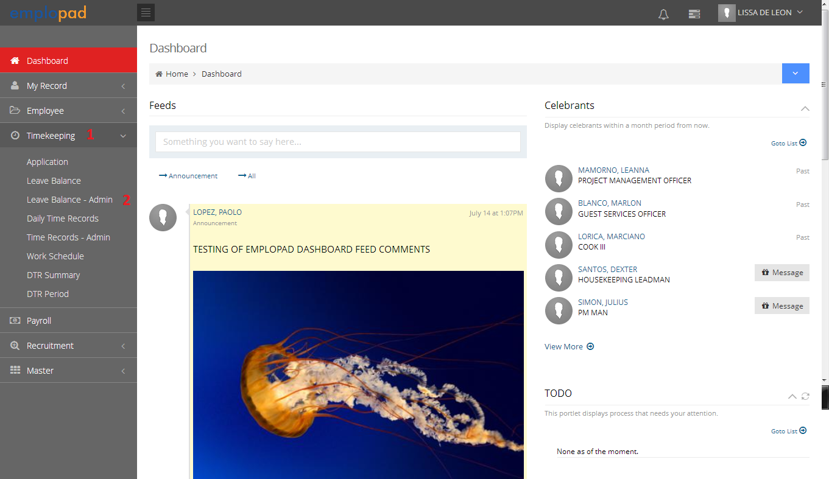

1. Search the employee name you want to check the leave balance.

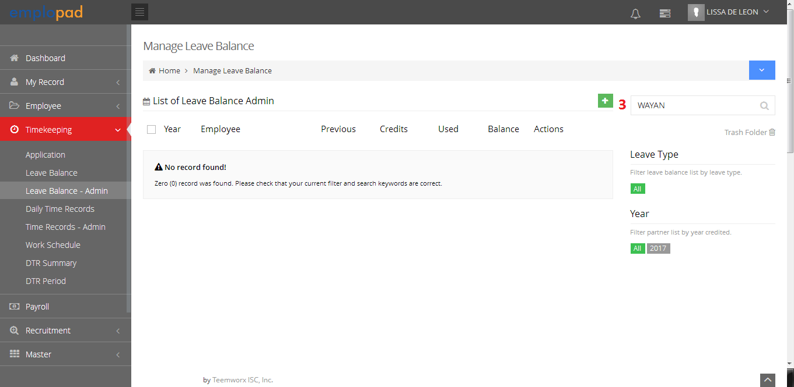

1. 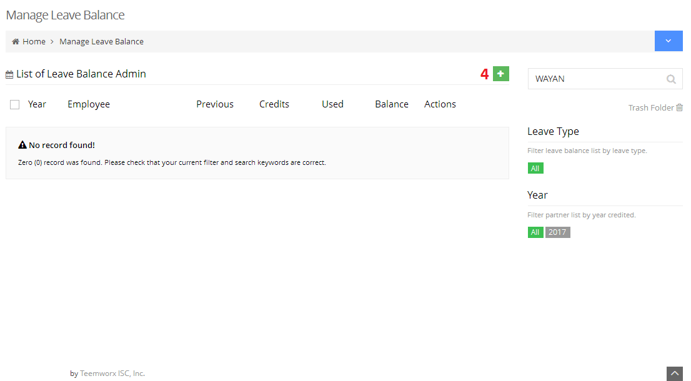To add leave credit, click add button
2. 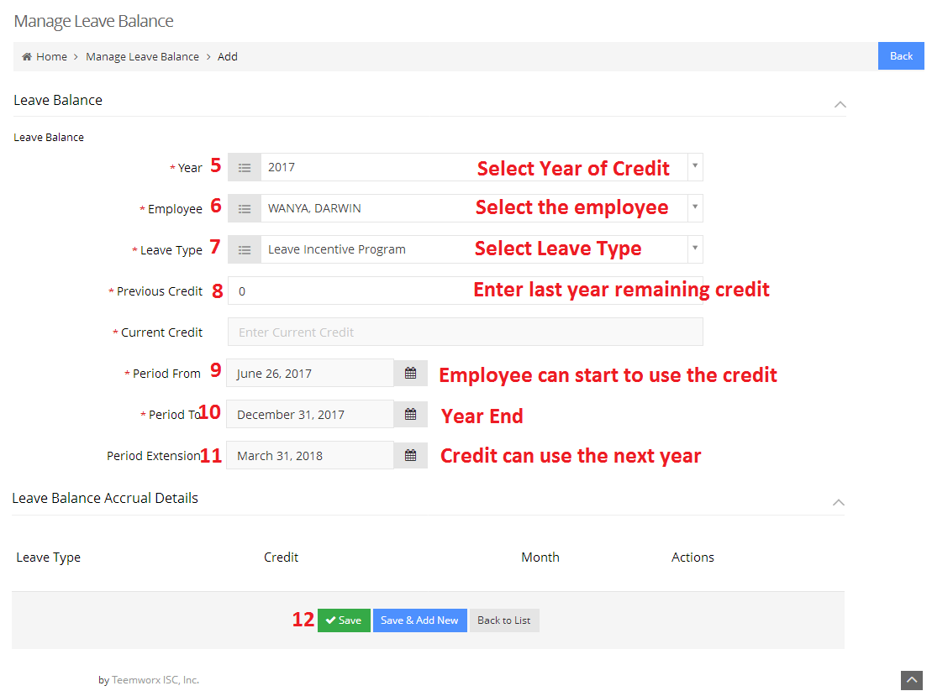Fill-up the required fields then click save button.
3. Click add button.

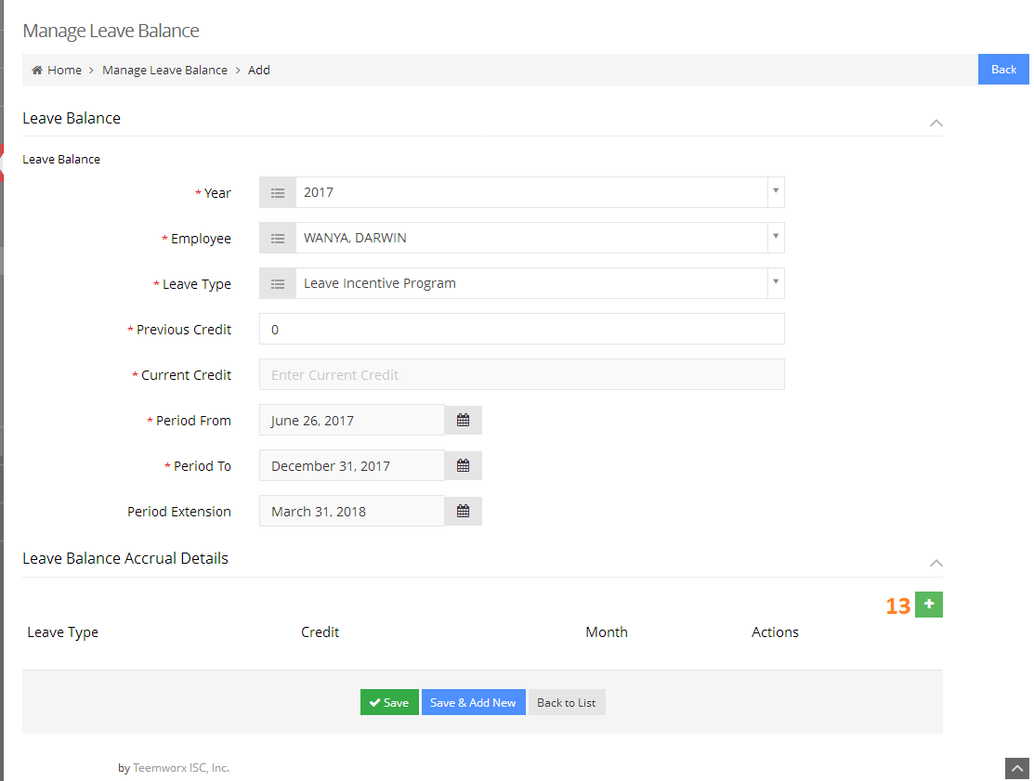

1. 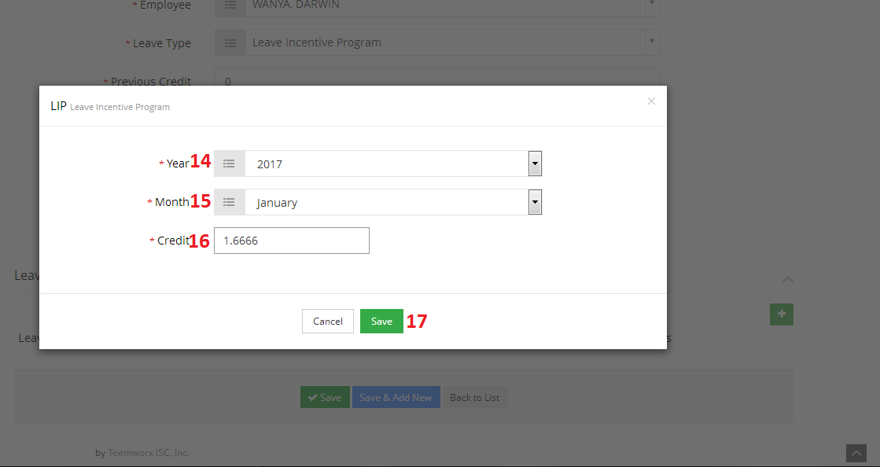Input the earned credit per month the click save button.
2. Repeat procedure in adding credit per month to complete the total earned credit then click save button.

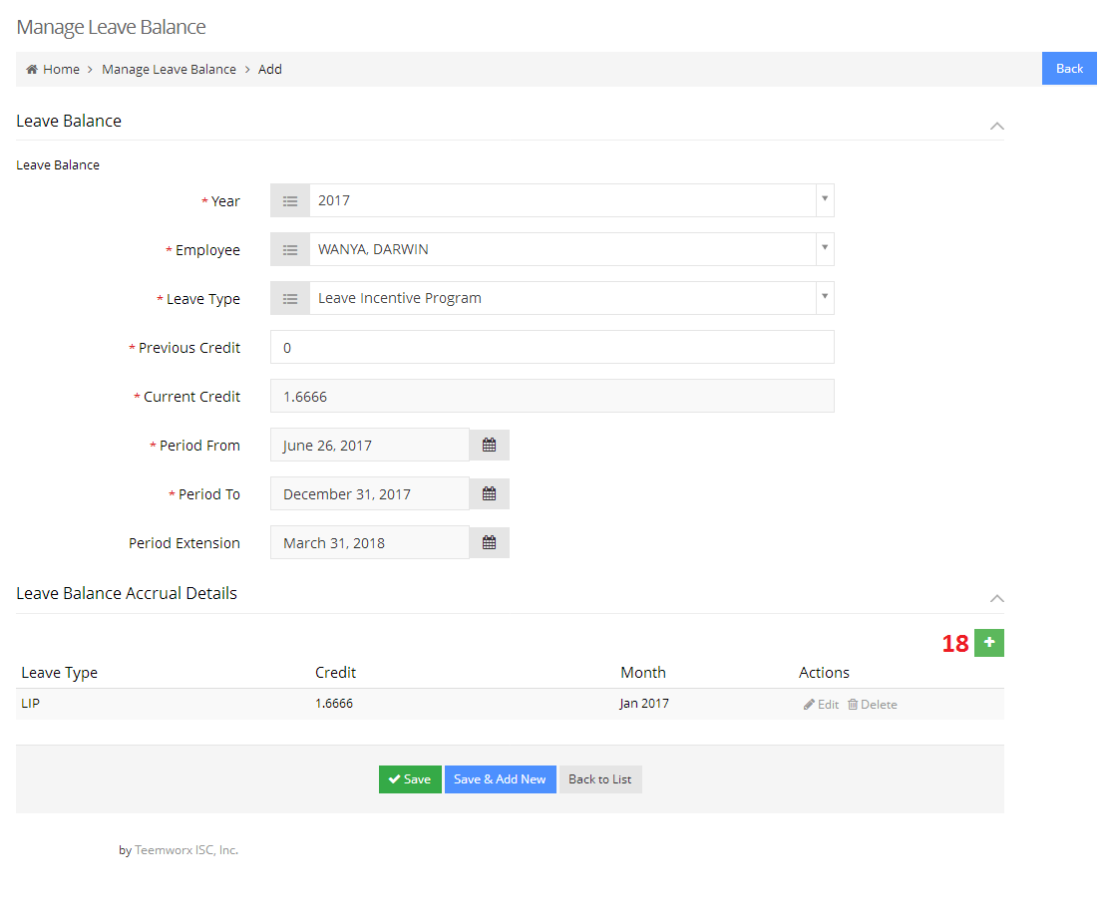

1. Total earned credit will reflected on the Current Credit field.

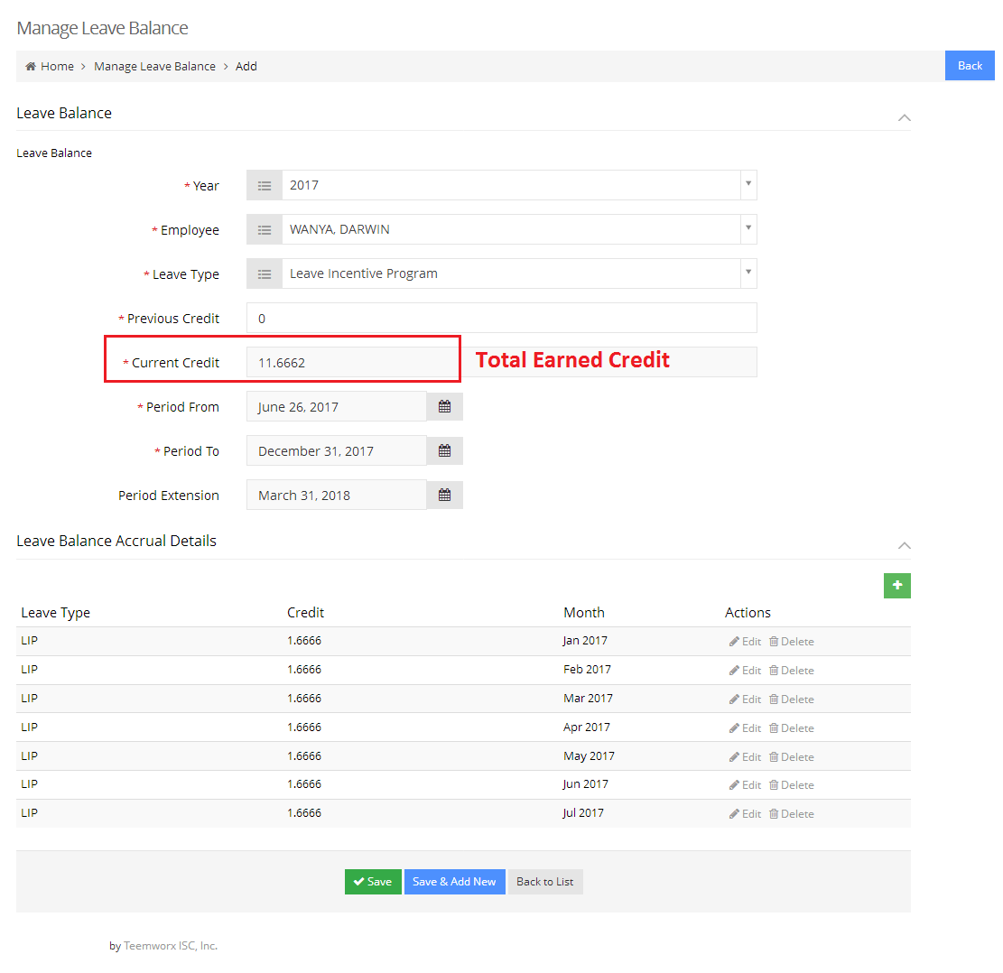

1. Leave Balance Listing per Employee

